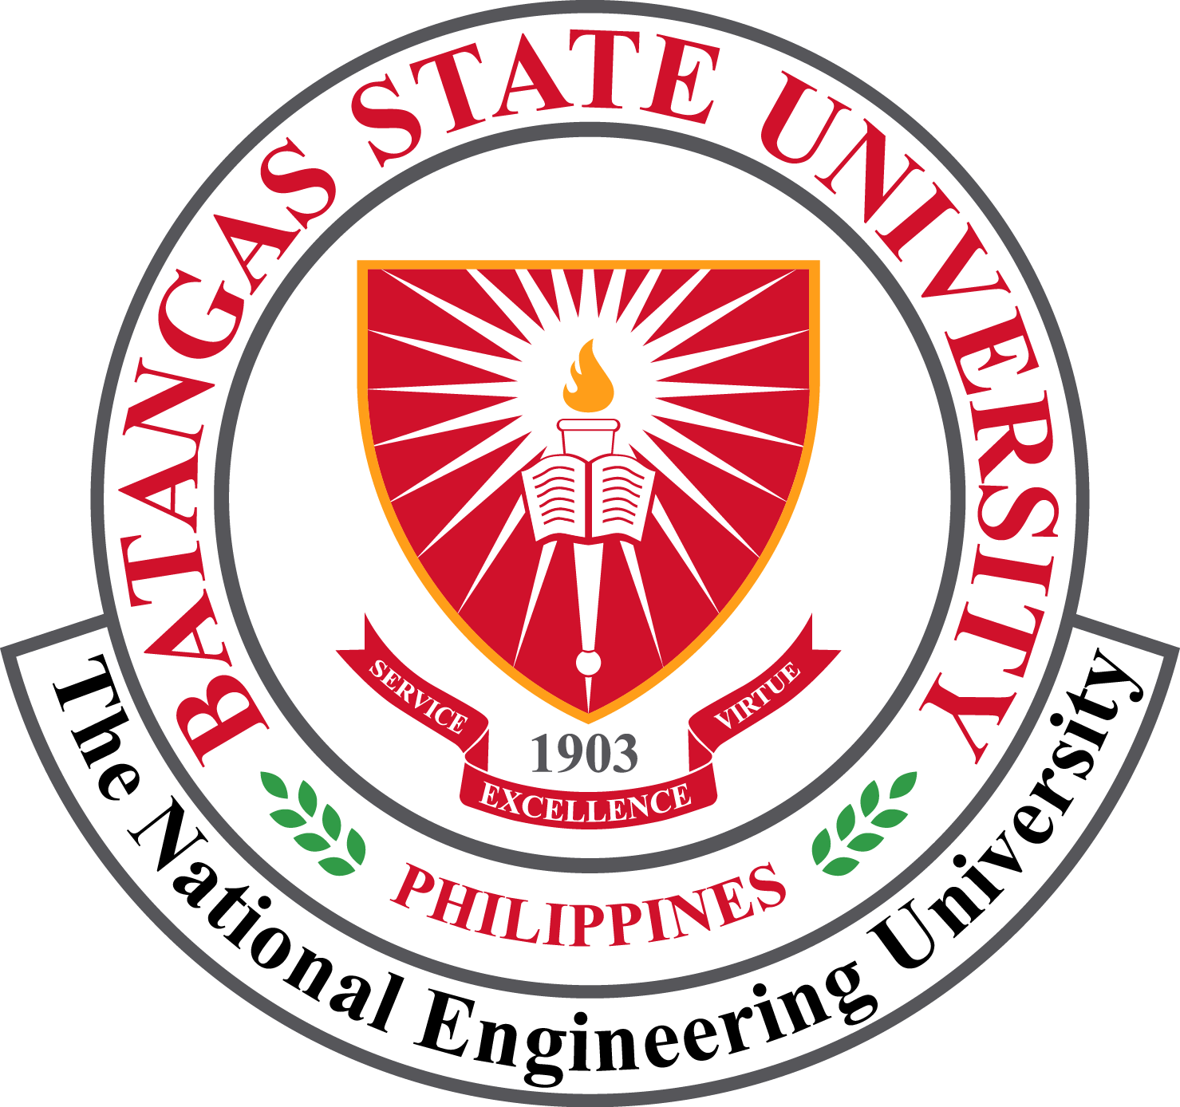
Reference No.: BatStateU-FO-SOA-01 Effectivity Date: May 18, 2022 Revision No.: 03

APPLICATION FOR RECOGNITION/RENEWAL OF STUDENT ORGANIZATION

August 12, 2026

Dr. DYEMNAH INASIAH P. BENTIR

The Communication Arts Society wishes to apply for Renewal to function as a curricular/co-curricular/extra-curricular student organization in the Batangas State University The National Engineering University, ARASOF-Nasugbu for the academic year 2026-2027

In this connection, we respectfully request your good office to grant its permission to operate as a College-based Student Organization, subject to the existing rules and regulations of our university.

Thank you very much.

Respectfully yours,

Mr. IANE ARVIN BLAIRE C. LACAP
Organization President
BatStateU The NEU ARASOF-Nasugbu
Reviewed by:  Ms. MA. MARUSKAH Z. NACIONAL, MC  Adviser, Communication Arts Society  Date: | Ms. COLLINES A. DELOS REYES, LPT, RFP  CAS Coordinator  Date:
Recommending Approval:

Dr. MARIA LUISA A. VALDEZ
Dean, College of Arts and Sciences
Date:
Approved by:

Dr. DYEMNAH INASIAH P. BENTIR
Head, Student Organization
Date:

Required Attachments: (A) Commitment Letter of the Adviser, (B) Certification of Academic Qualifications, (C) Profile of Student Organization, (D) List of Members, (E) History of the Student Organization, (F) Declaration of the Organization’s Revolving Fund, (G) Ratified Constitution and By-Laws, (H) Student Organization Adviser and Officers Profile, (I) Plan of Activities, (J) List of Officers’ Specimen Signature

Tracking Number: ___________________________

